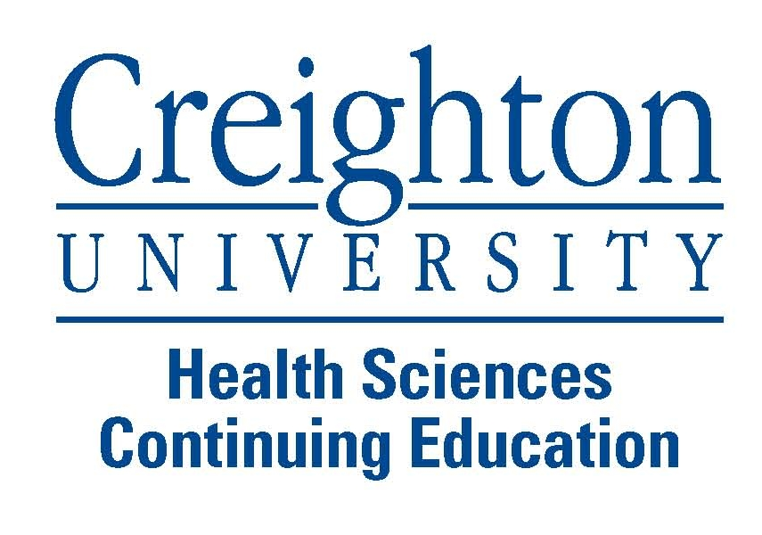
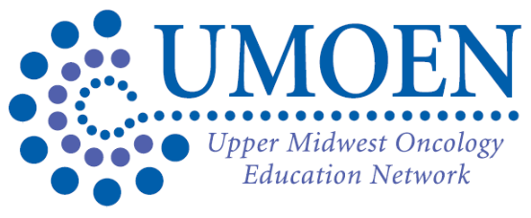
Annual Meeting Tentative Agenda
Saturday, November 2nd, 2013
Southview Country Club
239 Mendota Rd E,
West St. Paul, MN 55118
0700-0745 | Registration, Continental Breakfast & Industry Displays  (Display Area)
0745-0800 | Welcome and Program Overview Jeremy Whalen UMOEN President  0.25 CEU
0800-0900 | Keynote Speaker: Heidi D. Finnes, Pharm.D., BCOP  Topic: Healthcare Provider, Survivor of Cancer  1 CEU
0900-1000 | Lung Cancer Updates: Balkrishna Jahagirdar, MBBS  1 CEU
1000-1030 | Break and Industry Displays, Vendor Treasure Hunt, etc.
1030-1130 | Palliative Care and Hospice: Joseph Sicora, MD  1 CEU
1130-1230 | Lunch  Commercially Supported Program
1230-1300 | Break and Industry Displays, Vendor Treasure Hunt
1300-1400 | Medical Marijuana: A clash between nature, science and government:  Alex Kappelman, PharmD, BCOP  1 CEU
1400-1500 | New Drug Review: Jocelyn Mohs, PharmD, BCOP  1 CEU
1500-1515 | Break and Industry Displays, Vendor Treasure Hunt
1515-1615 | Growth Factor Debate: Rebecca Fahrenbruch, PharmD, BCOP & Jean Pupkes, MSN, APRN-BC, AOCN  1 CEU
1615-1630 | Closing Remarks and Prize Drawing: Monique Giordana and Shirley Kern UMOEN
The Creighton University School of Medicine designates this live activity for a maximum of 6.25 AMA PRA Category 1 Credit(s) TM. Physicians should claim only the credit commensurate with the extent of their participation in the activity

AAPA accepts AMA category 1 credit for the PRA from organizations accredited by ACCME.

The Creighton University Health Sciences Continuing Education designates this activity for 6.25 contact hours for nurses. Nurses should claim only credit commensurate with the extent of their participation in the activity.

Nurses licensed in Iowa and California: This activity was planned and developed in accordance with the continuing education standards of the American Nurses Credentialing Center (ANCC). The Iowa Board of Nursing and the California Board of Nursing will honor ANCC continuing education credits for face-to-face programs held outside Iowa and California, or for ANCC-approved online recorded courses taken in a self-study format.

The 1st Annual Upper Midwest Oncology Education Network Conference is sponsored by Creighton University Health Sciences Continuing Education (HSCE). HSCE is accredited by the Accreditation Council for Pharmacy Education (ACPE) as a provider of continuing pharmacy education. This activity is assigned Universal Activity (UAN) # 0839-9999-13-033-L04-P and is accredited for 6.25 hours for attendance of all CE sessions November 2, 2013. The 1st Annual Upper Midwest Oncology Education Network Conference is a knowledge-based CE activity.

ACCREDITATION STATEMENT:
This activity has been planned and implemented by Creighton University Health Sciences Continuing Education and the Upper Midwest Oncology Education Network (UMOEN) for the advancement of patient care. Creighton University Health Sciences Continuing Education is accredited by the American Nurses Credentialing Center (ANCC), the Accreditation Council for Pharmacy Education (ACPE), and the Accreditation Council for Continuing Medical Education (ACCME) to provide continuing education for the healthcare team.
UPPER MIDWEST ONCOLOGY EDUCATION NETWORK 5700 102nd Avenue North • Brooklyn Park, MN 55443 Phone: (651)324.9534 • Fax: (651)493.3528

